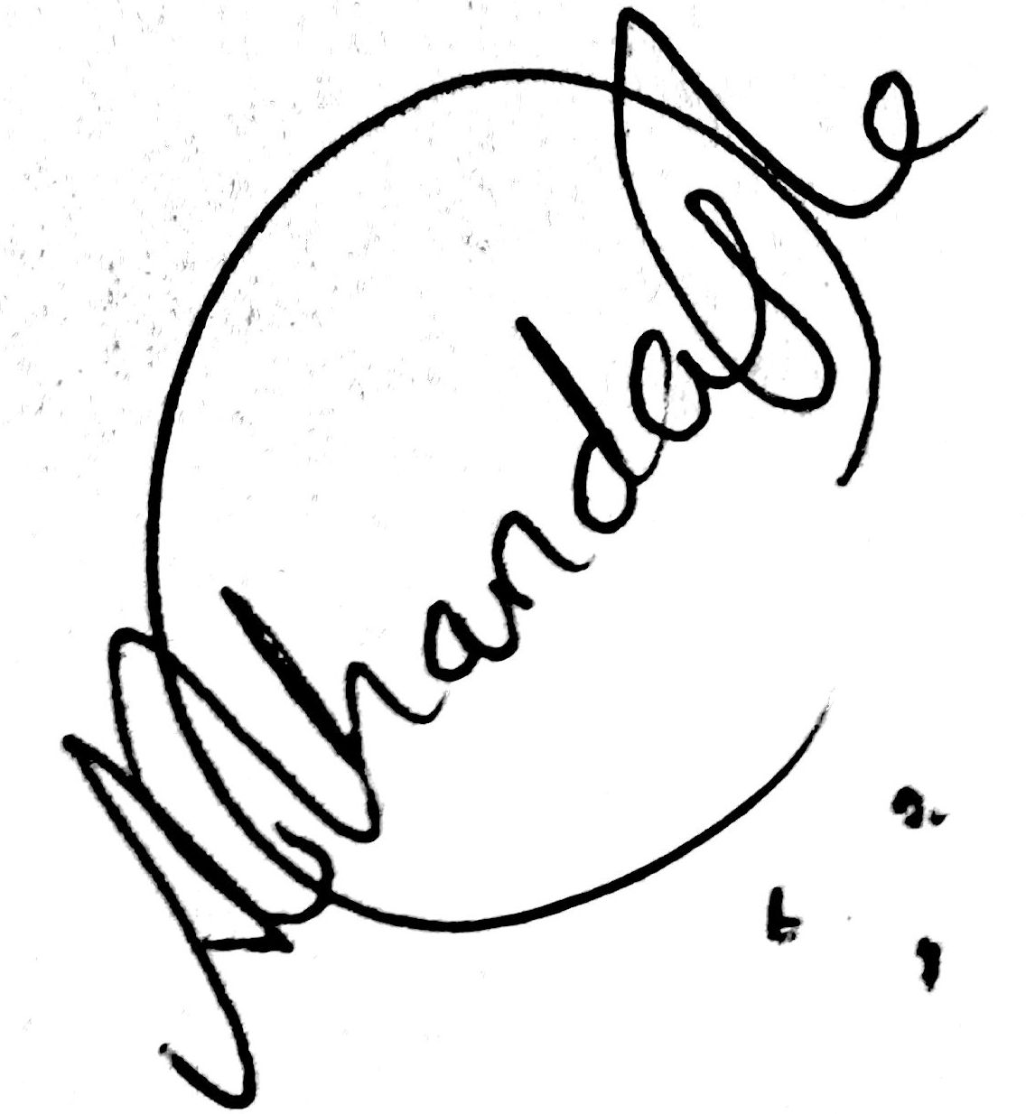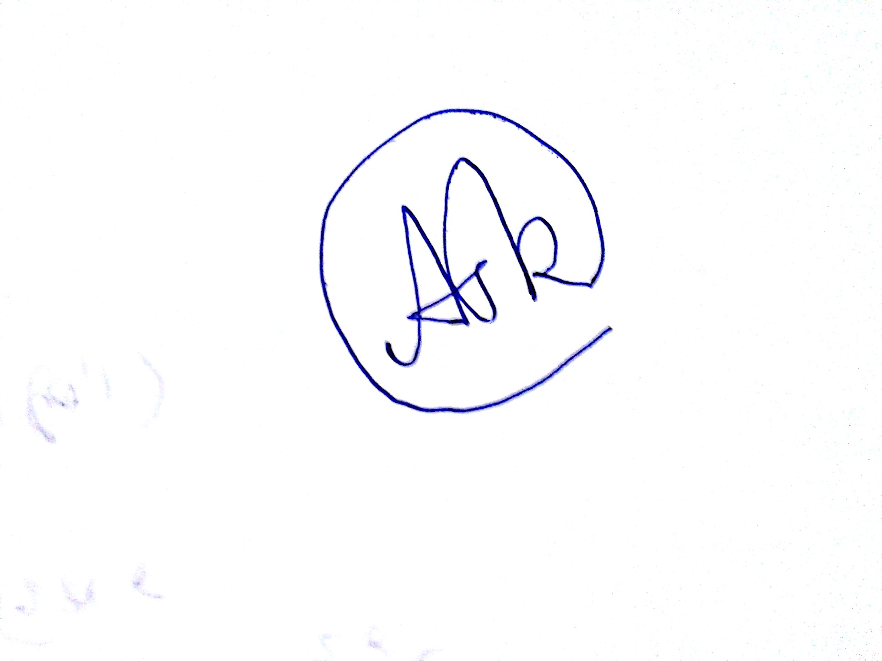SIGNATURE 1 SIGNATURE 2

Scientific Computing

Mid-sem ASSIGNMENT

# A ANURAAG KHANDAGLE – 130123007

# DATE – 04/10/2015

**Contents**

* Algorithm
* Q1

1. Point Extraction
2. Plotting the image

* Q2

1. Point Extraction
2. Plotting the image

* Conclusion
* In the cubic spline method, the function is constructed using –

Sj = aj + bj (x-xj) + cj(x- xj)2+ dj (x- xj)3 , given the values of a’s, we find the values of b, c, d for different intervals along the entire curve of the function.

* In the assignement , we use Parametric Cubic Spline.
* 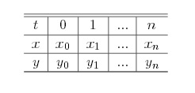We read the x and y coordinates from an excel file which are actually the points that are extracted from the image. We run a paramter t for the given n points and plot x vs t and y vs t.
* That means, we construct a cublic spline both for x coordinates and y coordinates. Let the cubic spline for x coordinates be X(t) and Y(t) for y coordinates.That is, we have actually generate the values of bx,cx,dx and by,cy and dy.
* Now in order to know the value of X(t) and Y(t), we divide each interval of t into 10 equal parts and calculate the X(t) and Y(t) in the following way as seen in the code :

x[i]= (dx[temp]*pow(tp,3))+ (cx[temp]*pow(tp,2))+ (bx[temp]*pow(tp,1))+ x[temp];

y[i]= (dy[temp]*pow(tp,3))+ (cy[temp]*pow(tp,2))+ (by[temp]*pow(tp,1))+ y[temp];

temp represents the index of the different intervals.

tp represents t-t[i], where t[i-1]<=t<=t[i].

* Example : If we have 20 points , then we have 19 intervals.We divide each interval into 10 parts in order to plot the curve.
* Now each interval of the paramater has unique values of a, b, c and d. Now, x-x[j] here is equivalent to t-t[j] both for X(t) and Y(t) where, t[i-1] <=t<=t[i].
* Therefore, in this we have a plot of X(t) and Y(t). Now, these values of X(t) and Y(t) actually plot the function.

## OBJECTIVE-

* To draw a spiral and reproduce it using parametric spline functions

## Points extraction

* Image extracted using – WebPlotDigitizer
* 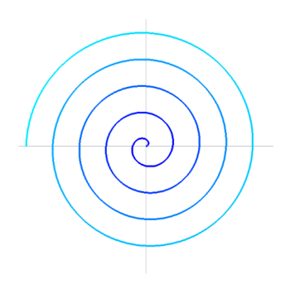Image before extraction of points
* 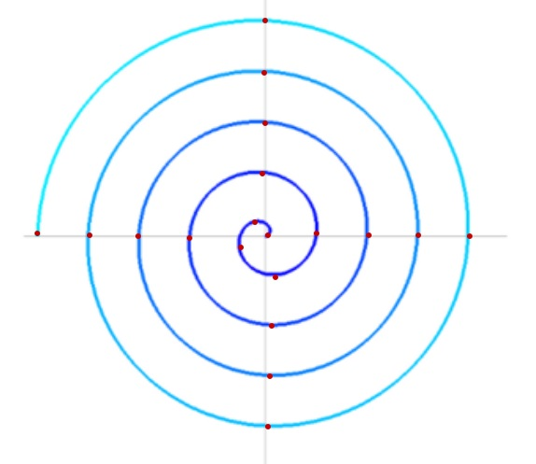Image after extraction of points. The red points indicate the points selected
* Total points extracted =19

## Plotting the image using Cubic Spline

* 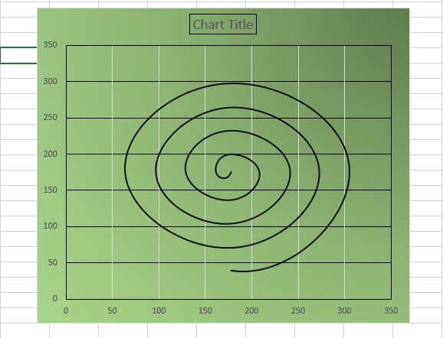Image after running the Cubic Spline algorithm for the spiral curve given
* Image plotted using Microsoft Excel

## Objective-

* To plot our own signature using maximum 20 knots and cubic spline

## Points Extraction

* Points extracted using WebPlotDigitizer
* Image before extraction
* 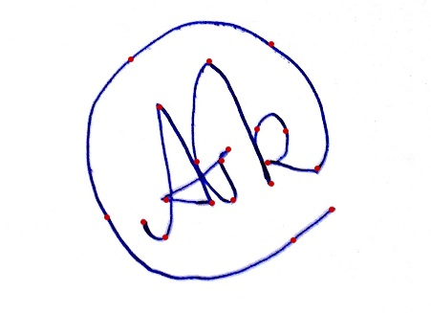Image after extracting the points. The red points indicate the points selected
* Total points extracted - 20

## Plotting the image using Cubic Spline

* 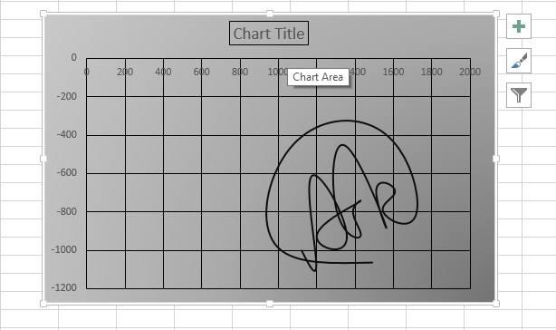Image after running the Cubic Spline algorithm for the spiral curve given
* Image plotted using Microsoft Excel.

# Signature 2 (more than 20 points )

* Original Image

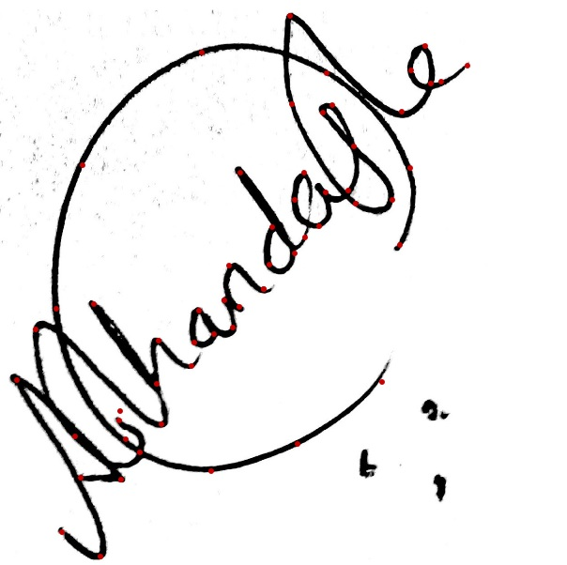

* Image after extracting the points

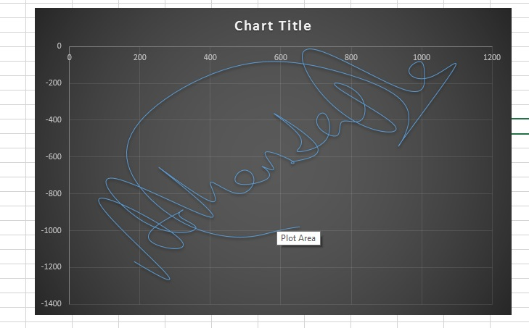

* Image after plotting
* The parametric spline equation were successfully found out and also the image was plotted
* The plot requires more number of initial points for curves having a lot of curvatures.
* Cubic lines prove to be the best for continous curves.